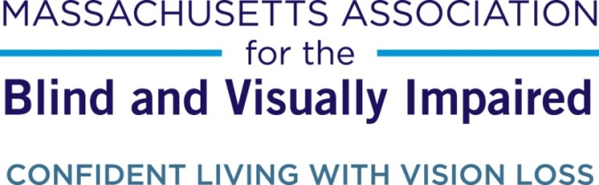

Arlington resident selected to receive Jane Falk Award for volunteer work from the Massachusetts Association for the Blind and Visually Impaired

Contact: Brian Klotz, Marketing Coordinator, (617) 732-0264, bklotz@mabcommunity.org

March 26, 2015

Boston, MA – On April 19th, the eve of the Boston Marathon, Arlington resident Dave Couture will be honored with the Jane Falk Award for Distinguished Volunteer Service from the Massachusetts Association for the Blind and Visually Impaired (MABVI). Dave has served as a one-on-one volunteer with Ken Bowles, who is visually impaired, for the past 21 years, offering his sight whenever needed. The two have become so close, however, that David no longer even considers it volunteering.
“Ken’s my friend,” he says.
Indeed, since the moment Dave and Ken were paired up as part of MABVI’s one-on-one volunteer program, they knew they were a perfect match. They are the same age (now 72), have the same politics, and even both grew up in Cambridge, where Ken has lived since the late 60’s. They also share a love of dogs – Dave notes that their 21-year relationship has spanned four service dogs for Ken, and Dave was excited when Ken, whose previous service dogs had all been German Shepherds, got his current dog: a golden retriever named Finnegan.
“I am totally, unequivocally in love with all golden retrievers,” says Dave, who has one of his own named Tucker.
A proud member of the Knights of Columbus, Dave is a strong believer in giving back, which is what inspired him to sign up to volunteer with MABVI when a co-worker brought a flyer into work. Having no experience with individuals who are visually impaired, MABVI’s training helped him understand what to expect.
“They made it clear that one size doesn’t fit all,” he says. “Every person needs different help.”
When they get together, Dave assists Ken with paying bills, readings mail, doing errands, and other such tasks, in addition to walking with their dogs. While volunteers and their matches often have a set schedule when they will meet, after 21 years this particular pair now takes a less formal approach, getting together whenever Ken needs help.
“If he needs to he can call me at any time,” says Dave. Often these calls are computer-related, as Ken, like many individuals who are visually impaired, often struggles with websites that are not accessible to users with low vision. Dave relates one example of Ken, an avid reader, ordering some books on Amazon but being unable to pay without sighted assistance.
Ken, a former social worker, still loves reading books on psychology and philosophy. He also enjoys traveling the world, having been to India, Korea, Russia, South America, Africa, and much of Europe, among other places (although he finds himself traveling less often these days as his eyesight worsens).
“He’s very adventurous,” Dave says of his friend. “Extremely intelligent, well-read.”
For his part, Ken cannot say enough about how appreciative he is to have Dave as a volunteer and a friend.
“He makes my life a lot easier,” says Ken. “He’s a very generous, kind, caring person – an all-around really good guy.”
What began as volunteering for a stranger 21 years ago has evolved into a friendship, so will it ever come to an end?
“We don’t know any reason why he’d ever stop,” says Dave. “I can’t imagine ever saying I couldn’t come over anymore.”
Dave will receive the Jane Falk Award at a Volunteer Appreciation Brunch on April 19th at the Westin Copley Place in Boston. Each year MABVI presents the Jane Falk Award for Distinguished Volunteer Service to one volunteer who has creatively and generously participated in fostering the ideals, services, and mission of the organization. Jane Falk was a volunteer and former President of the Board of Directors for MAB Community Services (MABVI’s parent organization). She believed strongly that individuals should seek the opportunity to give back to their communities, and that those volunteers should be recognized for their efforts. The award was established in 1983 in Jane’s memory.​
Anyone interested in becoming a volunteer can apply at mabvi.org/volunteer or call (617) 926-4312. Individuals under 18 may volunteer alongside a parent as part of MABVI’s Family Volunteer Program.

###

ABOUT MABVI:
The Massachusetts Association for the Blind and Visually Impaired has been creating opportunities for people with vision loss since 1903. Our experience allows us to forge strong community partnerships to meet the pressing need for high quality services and transform lives. www.mabvi.org

