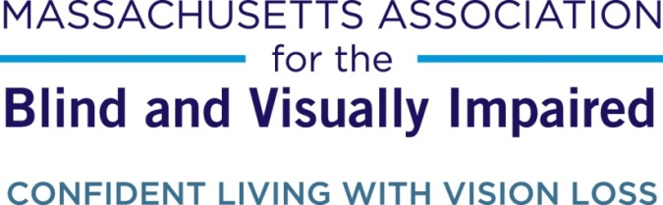

Volunteer for the Blind Program Leads to Lifelong Friendship for Quincy Woman

Contact: Brian Klotz, Marketing Coordinator, (617) 732-0264, bklotz@mabcommunity.org

November 20, 2014

Quincy, MA - When Valerie Richardson first approached the Massachusetts Association for the Blind and Visually Impaired (MABVI), she was just looking for a volunteer to help her with routine tasks, but what she got was a friend. For the past ten years, retired engineer Kenny Paul, now 66, has made a weekly visit to Quincy, where he helps Valerie with grocery shopping, reading mail, writing checks, and other tasks that would be difficult for a blind person to do.
The arrangement, made possible by MABVI’s volunteer program, quickly blossomed into a friendship. Kenny and Valerie met each other’s families. They went out to dinners. Kenny dog-sat for Valerie’s guide dog, a yellow lab named Tess who likes to get rambunctious when not “on the job.” Five years ago, Valerie even braved a hurricane to attend Kenny’s wedding.
“She’s a great lady,” says Kenny. “I’ve always enjoyed working with her.”

The feeling is mutual.

“Kenny is patient, he’s funny, and he loves to help,” says Valerie. “He wants to make sure he does everything exactly right.”

Like most of the consumers in MABVI’s volunteer program, the 60-year-old Valerie is independent, living on her own and able to accomplish most tasks without assistance. Having no sight does little to dampen her spirits. Always maintaining a positive attitude, Valerie’s enthusiasm is infectious, and she keeps her days filled with varied activities: she loves reading, she sings in her church choir, and she is taking piano lessons at the South Shore Conservatory in Hingham, revisiting a dream that she mostly abandoned in her late teens. She has even written a memoir and is currently looking for a publisher.

“I keep busy,” she says. “And I help people however I can.” That’s right: Valerie herself is no stranger to assisting others, having previous worked in a children’s hospital, at a homeless shelter, and as a preschool teacher.

Kenny began working with Valerie after a friend of his, who had been volunteering with Valerie for seven years, moved out-of-state. In need of a new volunteer, Kenny, who has a lifetime of experience offering his time to help others, was more than happy to step in.

“I’ve been very fortunate in my life, and I believe you’ve got to give back,” says Kenny. “I guess my parents instilled that in me.”

Kenny’s advice to anyone considering volunteering for a blind or visually impaired person? “Don’t go in with any preconceived notions, and don’t underestimate their abilities. Let them guide you.” Indeed, Kenny notes how he continues to be amazed by, for example, Valerie’s spatial awareness: “I’ll be moving things for her, and she’ll always know exactly where a piece of furniture will fit!”

This observation – that one should not underestimate a person’s capability simply because they are visually impaired – reflects the core mission of MABVI and its volunteer program: to help individuals with vision loss maintain their independence and lead the lives they want to live in their own homes and communities. Volunteers, who typically visit for an hour or two each week, provide assistance for whatever common tasks the consumer wishes. Depending on their level of need, a consumer may have multiple volunteers at a given time.

Valerie, who now has had a MABVI volunteer for 17 years in total, was particularly impressed with MABVI’s commitment to making consumers feel comfortable with their volunteers. This includes conducting thorough interviews and background checks, as well as training each volunteer on topics such as how to interact with and guide a visually impaired person.

“We pride ourselves on the quality of our volunteer services,” says Kyle Robidoux, MABVI’s Director of Volunteer and Support Group Services. “We’ve been very lucky to have such a great group of people willing to offer their time, but the demand is very high.”

Currently there are over 50 visually impaired individuals throughout Massachusetts still seeking a volunteer, including five in Quincy alone. Unfortunately, Valerie will be one of them come December, as Kenny will no longer be able to serve as her volunteer.

Not that Valerie will let that get her down.

“I have been tremendously blessed, and got to make new friends,” says Valerie of her MABVI volunteer experience overall. “It’s been a joy and a blessing.”

Anyone interested in becoming a volunteer can apply at mabvi.org/volunteer or call (617) 926-4312. Individuals under 18 may volunteer alongside a parent as part of MABVI’s Family Volunteer Program.

###

ABOUT MABVI:
The Massachusetts Association for the Blind and Visually Impaired has been creating opportunities for people with vision loss since 1903. Our experience allows us to forge strong community partnerships to meet the pressing need for high quality services and transform lives. www.mabvi.org

